**Exercise: Optimizing a report for mobile**

**Introduction**

By now, you should have gained a solid understanding of the essential concepts of what visual clarity is and how to achieve it in reports. Appropriate chart selection, formatting visuals, accessibility considerations, and cellphone optimization are some of the ways you can create clutter-free, impactful reports in Microsoft Power BI.

In this exercise, you are asked to apply your knowledge to optimize a Power BI report for mobile devices.

**Scenario**

A senior Adventure Works marketing executive is traveling to Europe for business meetings. You must present a summary of the district sales report with a KPI that she can visualize on her way to the airport. A mobile-optimized version of the report is what is needed. As a report designer in Power BI, you can help by performing report optimization.

In this exercise, you will go through each step of optimizing an existing report for cellular devices.

By completing this exercise, you will demonstrate your ability to:

* Review the layout and design of a report page.
* Optimize an existing report for mobile devices.
* Apply mobile-only formatting to the optimized report.

Follow the exercise steps to optimize the report for mobile layout and ensure the visual elements in the mobile canvas are properly positioned and scaled to eliminate any visual clutter.

[Optimizing a report for mobile](https://d3c33hcgiwev3.cloudfront.net/tEZqTyjSRAWg2Q1cj8m3Xw_0c4915bfefcb4da9b2885cf8e93511e1_Optimizing-a-report-for-mobile.pbix?Expires=1712275200&Signature=HBWndQ-td-O0ENBTK0Tx6bIMq4pKyUiwMoGycgRTV1vaX5zp526qh1XH6R-Vd3YEpGutcttPzHQEEvnxfFzdZ6X9WhkMyRcq7vZ-hXlEv6Pe9az8~KSlZILGdMF4ZHW5eqouMu7d05D6E59567V6TGVLViVUwKQi6Lr5aA6uEdA_&Key-Pair-Id=APKAJLTNE6QMUY6HBC5A" \t "_blank)

[PBIX File](https://d3c33hcgiwev3.cloudfront.net/tEZqTyjSRAWg2Q1cj8m3Xw_0c4915bfefcb4da9b2885cf8e93511e1_Optimizing-a-report-for-mobile.pbix?Expires=1712275200&Signature=HBWndQ-td-O0ENBTK0Tx6bIMq4pKyUiwMoGycgRTV1vaX5zp526qh1XH6R-Vd3YEpGutcttPzHQEEvnxfFzdZ6X9WhkMyRcq7vZ-hXlEv6Pe9az8~KSlZILGdMF4ZHW5eqouMu7d05D6E59567V6TGVLViVUwKQi6Lr5aA6uEdA_&Key-Pair-Id=APKAJLTNE6QMUY6HBC5A" \t "_blank)

**Step 1: Download the Power Bi file**

* Download the *Optimizing a report for mobile.pbix* file, which you will use in this exercise. The report contains three visuals: a pie chart, a bubble chart, and a KPI visual.

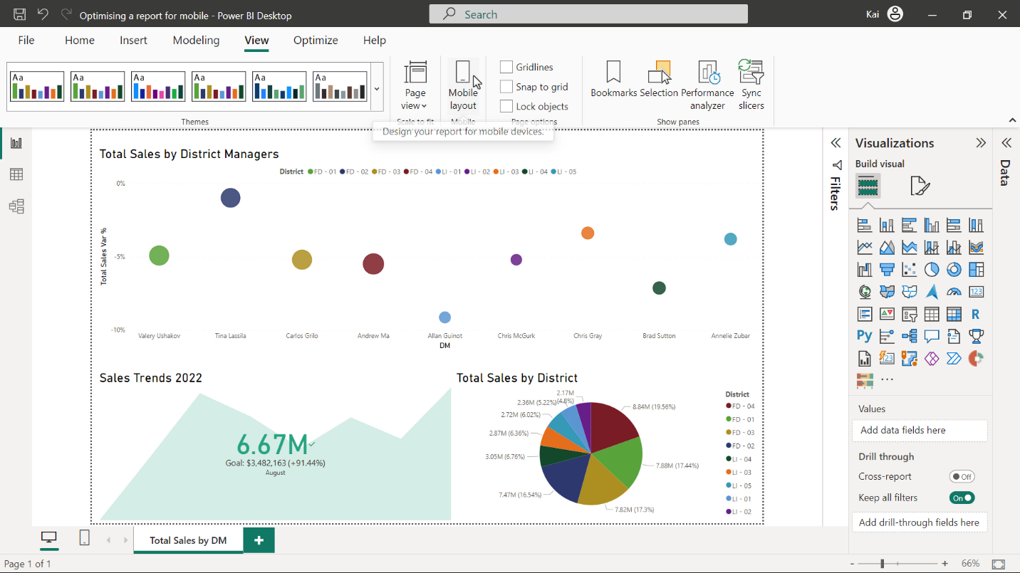

**Step 2: Review the layout**

* Start the task by reviewing the current layout and design and analyzing the sequence of visuals to be displayed on the mobile version of the report based on the importance of information.

**Step 3:  Move and format the KPI chart**

1. Move the KPI chart to the mobile canvas, position and rescale the chart appropriately to fill the mobile screen layout.
2. Format the chart visual to have a mobile-friendly font size for the title, axis, values, and legend.

**Tip:** You can optimize the report by navigating to **Mobile layout** of the **view** ribbon in Power BI desktop.

**Tip:** You can navigate to the **Visual** and **General** tabs of **Visualizations** pane for formatting the chart.

**Step 4: Move and format the bubble chart**

1. Move the bubble chart from the original report to the mobile canvas, position and rescale the chart appropriately to fit the mobile screen layout.
2. Format the visual with a mobile-friendly font size for title, axis, values, and legend. Confirm the changes are mobile-only and that they do not affect the desktop version of the report.

**Tip:** You can format any settings from the **Visual** and **General** tab of **Visualization** pane.

**Step 5: Move and format the pie chart.**

1. Move the pie chart from the original report to the mobile canvas, position and rescale the chart appropriately to fit the mobile screen layout.
2. Format the visual font size for a mobile-friendly title, axis, values, and legend. Confirm the changes are mobile-only, and that they are not affecting the desktop version of the report.

**Tip:** You can format any settings from the **Visual** and **General** tab of **Visualization** pane.

**Step 6: Save the project**

* Save your Power BI project to your local computer.

**Conclusion**

With these steps, you have successfully optimized a desktop Power BI report for cellular devices to meet the needs of managers and executives of Adventure Works.

**Exemplar: Optimizing a report for mobile**

**Overview**

In the exercise *Optimizing a report for mobile*, you put into practice your understanding of how to optimize a report for mobile in Power BI.

Your objective for this exercise was to complete the following tasks:

* Review the current layout and design of a report page.
* Optimize the report for mobile devices.
* Format the mobile properties of the visuals.

This reading provides a step-by-step guide for completing these tasks, accompanied by screenshots for easy comparison with your own copy. You can also review the video [*Optimizing report layout for mobile*.](https://www.coursera.org/learn/creative-designing-in-power-bi/lecture/M4duD/optimize-a-dashboard-for-mobile-phones)

[Optimizing a report for mobile](https://d3c33hcgiwev3.cloudfront.net/B-F8CS8DQZCh0sdZZNM14A_9ba734139f1e4fc19c663168be76bce1_Optimising-a-report-for-mobile-C6M2L1-Item-10-1-.pbix?Expires=1712275200&Signature=Sy7oJzCbV1NKO0MzRN8dGVfy-jDra3~ZExcW1Mtv02R7kRoEfTZfctN9yeTbsZC-2nDVAHfImh0rysoQFOLAZuDvSZHx2dTkXdG~z0Z11ojV5IznQWu4I5rvi3FABAadn2eaTB4h5PC1OKsfKqyK44flGSsaHEO0yCRS05c5cVI_&Key-Pair-Id=APKAJLTNE6QMUY6HBC5A" \t "_blank)

[PBIX File](https://d3c33hcgiwev3.cloudfront.net/B-F8CS8DQZCh0sdZZNM14A_9ba734139f1e4fc19c663168be76bce1_Optimising-a-report-for-mobile-C6M2L1-Item-10-1-.pbix?Expires=1712275200&Signature=Sy7oJzCbV1NKO0MzRN8dGVfy-jDra3~ZExcW1Mtv02R7kRoEfTZfctN9yeTbsZC-2nDVAHfImh0rysoQFOLAZuDvSZHx2dTkXdG~z0Z11ojV5IznQWu4I5rvi3FABAadn2eaTB4h5PC1OKsfKqyK44flGSsaHEO0yCRS05c5cVI_&Key-Pair-Id=APKAJLTNE6QMUY6HBC5A" \t "_blank)

**Step 1: Download the Power BI File**

Download the *Optimizing a report for mobile.pbix* file, which you will use in this exercise.

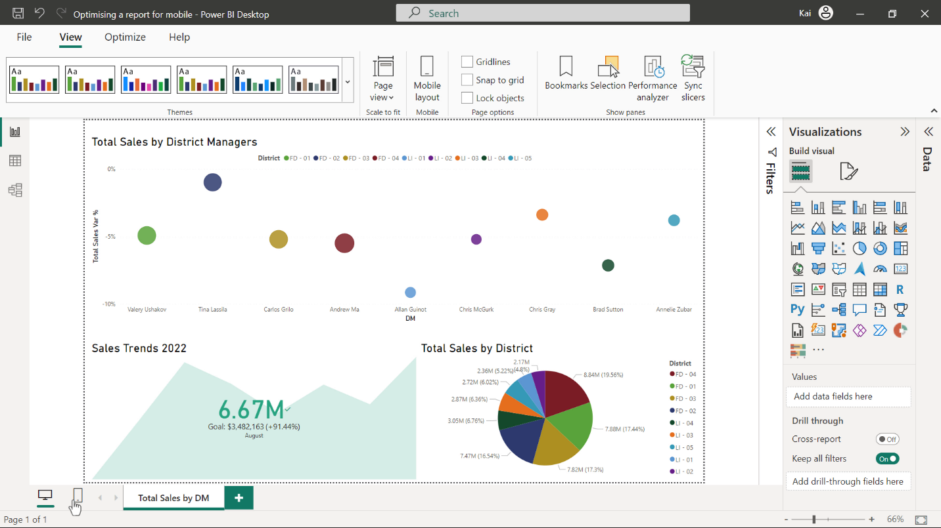

**Step 2: Review the report layout**

* The report contains three visuals. A pie chart representing the sales of various districts, a bubble chart showing the sales performance of district managers, and a Key Performance Indicator (KPI) displaying the sales vs. target values. Based on the information presented, the KPI visual contains the most valuable information about sales progress followed by a bubble chart and finally a pie chart.

**Step 3: Move and format the KPI chart**

1. You need to navigate to **Mobile layout** in the **view** ribbon of Power BI which opens a mobile canvas.



Next, you need to drag and drop the first chart (a KPI) from the **Page visuals** pane to the mobile layout canvas.

You can move the KPI chart at the top of the page and you need to re-scale and reposition the chart to fit the dimensions of the mobile screen.

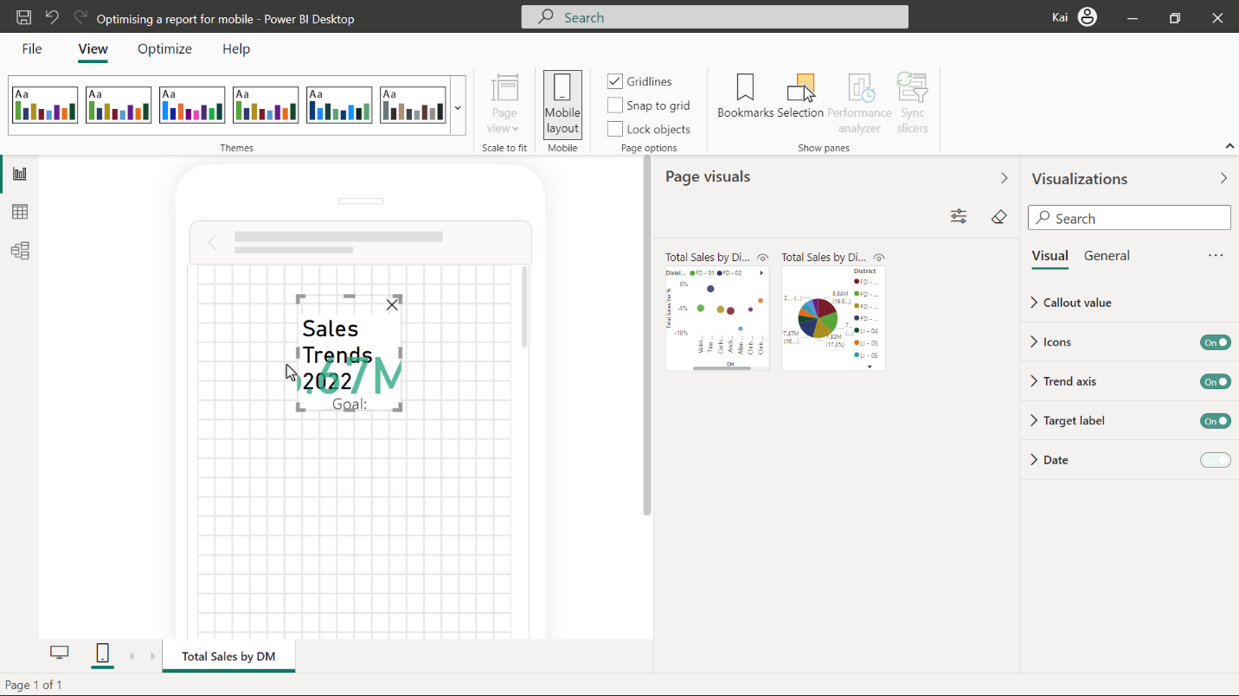

2. Once you move the KPI chart to mobile screen layout, both the chart title and values seem too big for a small screen. You need to navigate to **Visualization > General** and change the font size to **12**. To format the value, go to **Visualization > Visual**, expand the **callout** value, and change the font size to **32**. Scroll further down the callout value section, expand the **target label**, and reduce the target size to **10**.

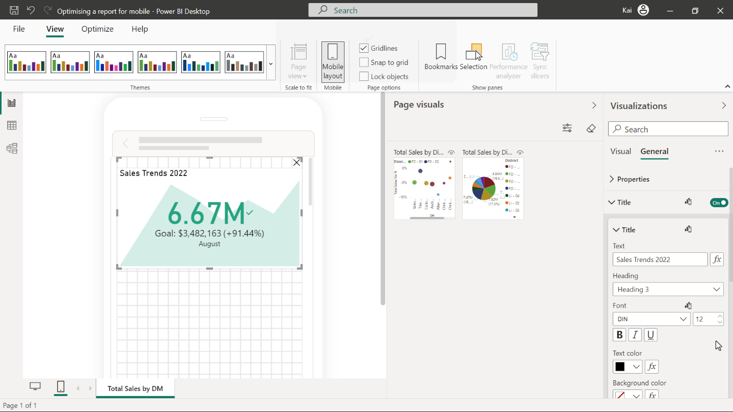

**Step 4: Move and format the bubble chart**

1. Next, drag and drop the bubble chart to the mobile layout pane of Power BI. You need to reposition and re-scale the visual below the KPI chart to fit the screen.

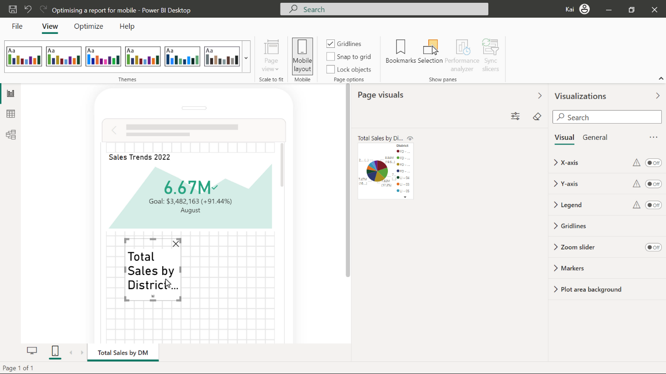

2. After moving to mobile canvas, the chart needs some formatting, the **x-axis label**, **y-axis label font size**, **title font size** all need adjustments. You need to adjust these font sizes to make the formatting consistent.

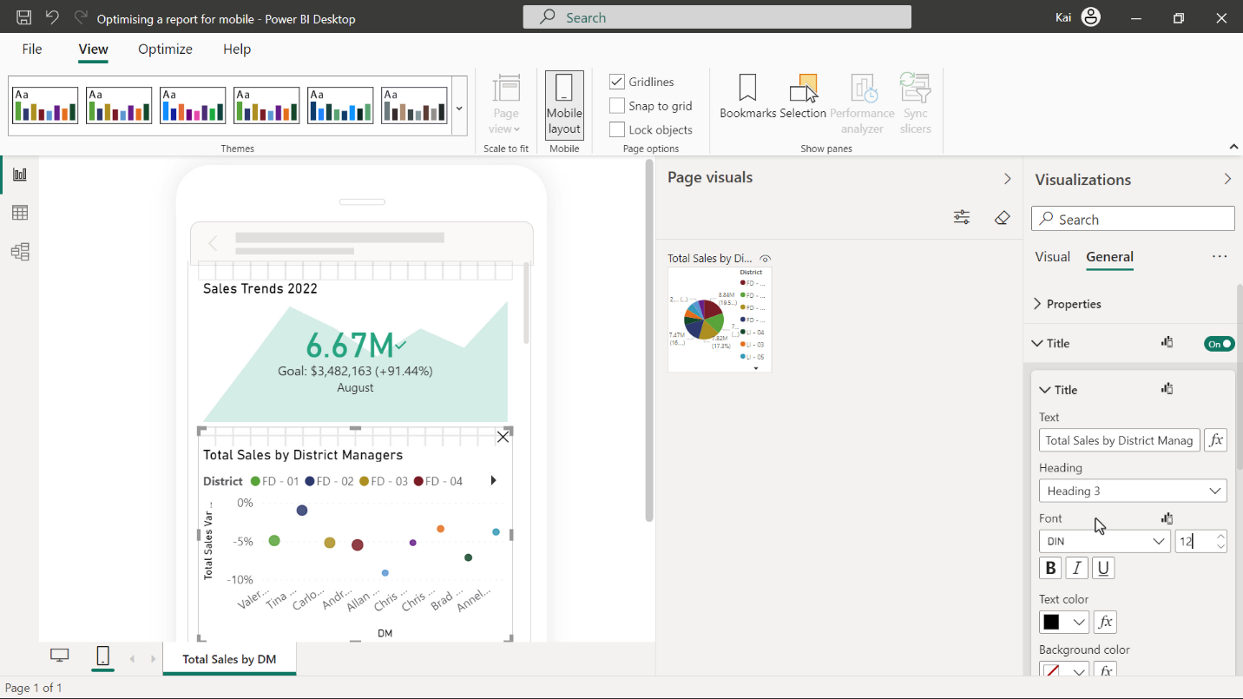

You can also turn the **legend title toggle button** to the **off** position.

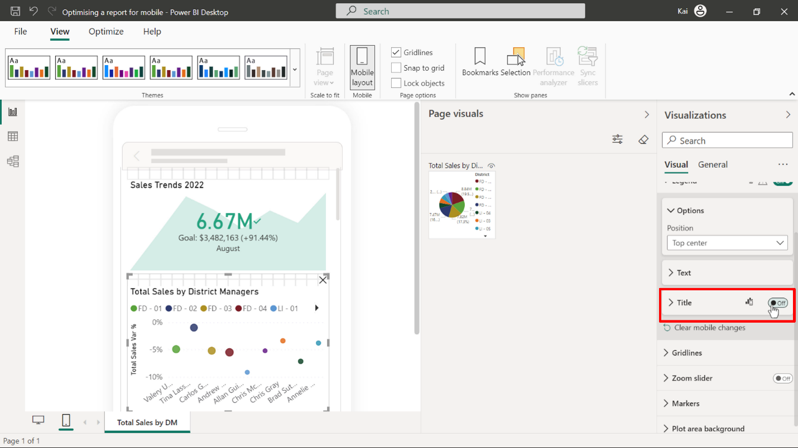

**Step 5: Move and format the pie chart**

1. Lastly, drag and drop the pie chart to the mobile layout pane of Power BI.

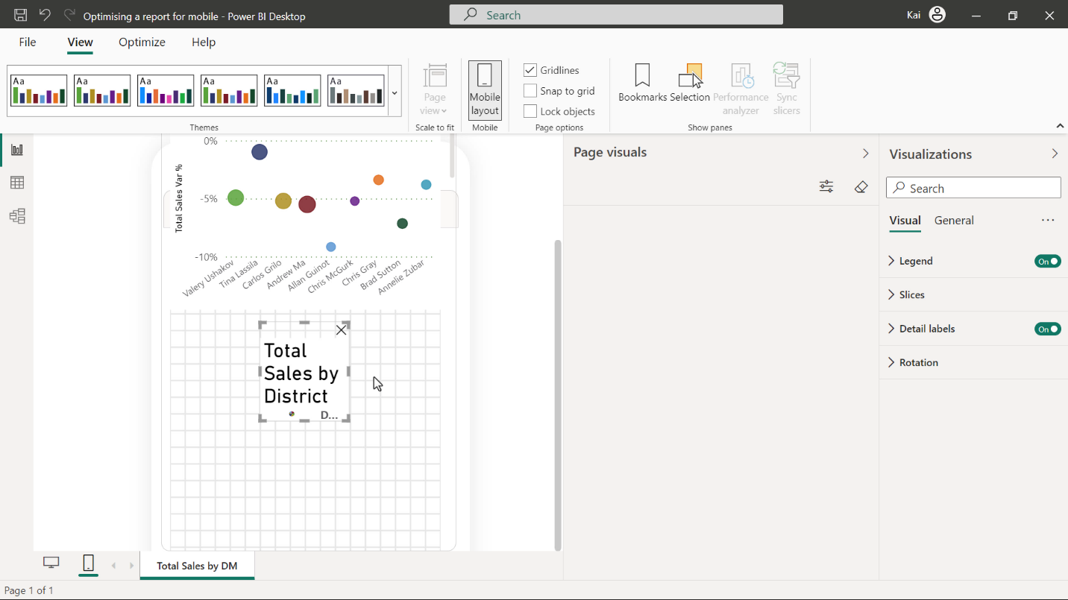

You need to reposition and re-scale the visual below the bubble chart to fill the screen.

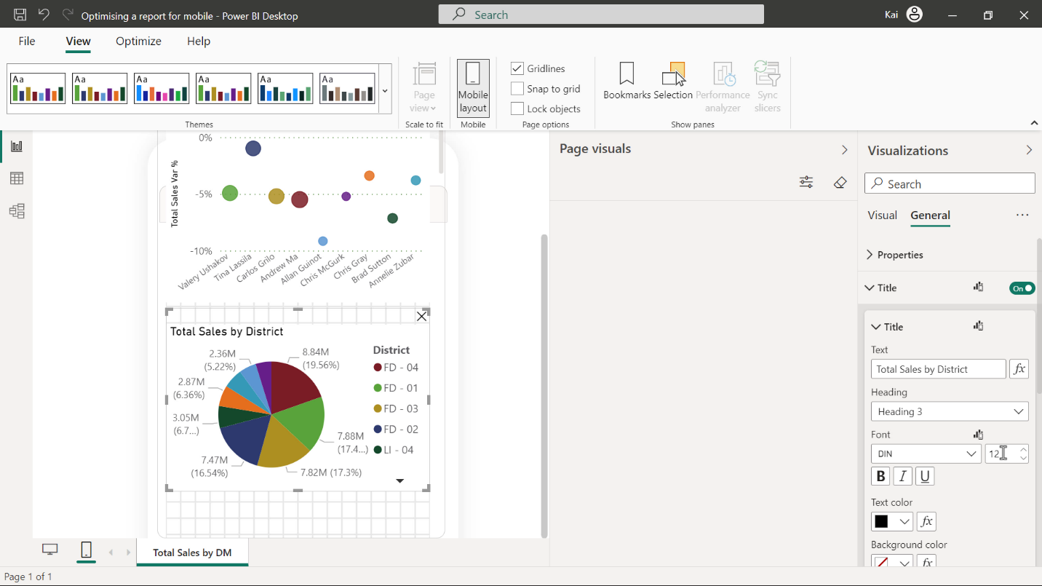

2. After moving to mobile canvas, the pie chart looks a bit cluttered and therefore needs some formatting adjustments. Reduce the **chart title font size** and set the **legend title** to the **off** position.

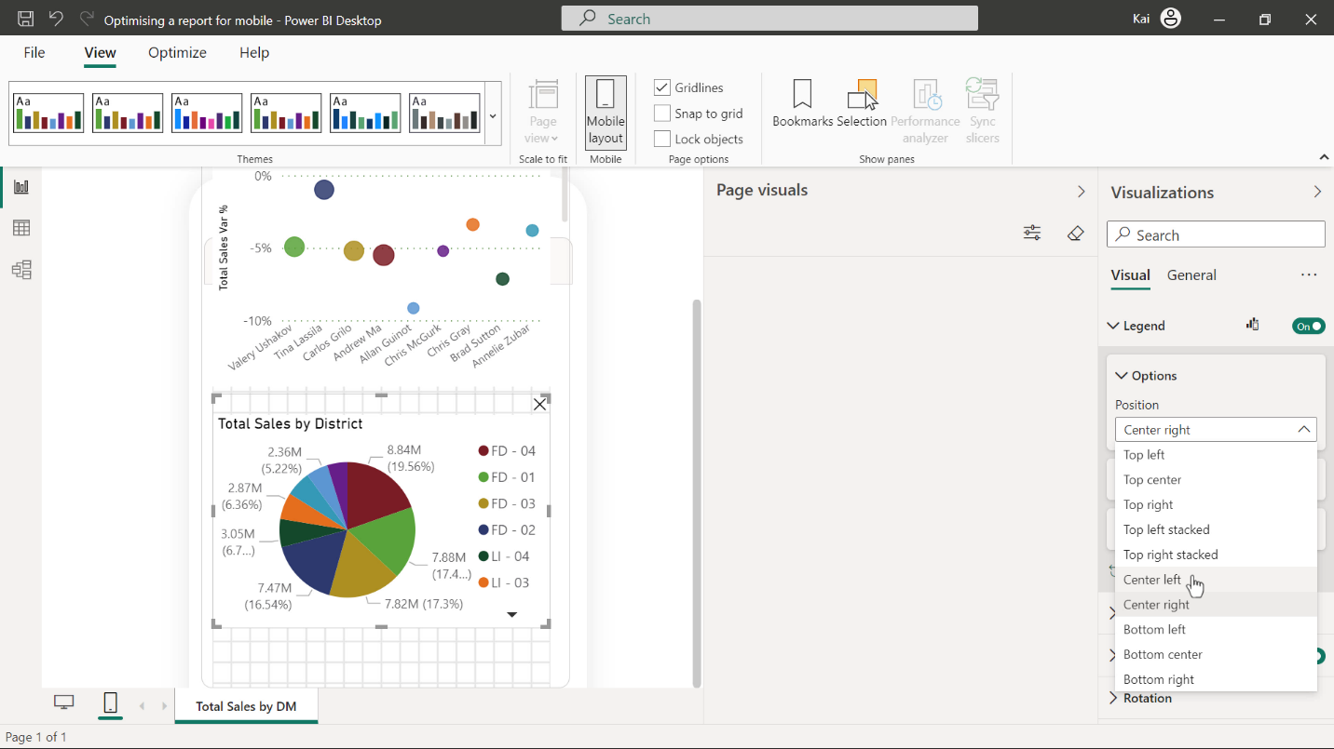

The data values on the pie chart slicers are not easily readable. Navigate to **Visual**, expand **data labels** and in the **label content** drop-down select **Data value**. This will remove the visual clutter from the pie chart slices.

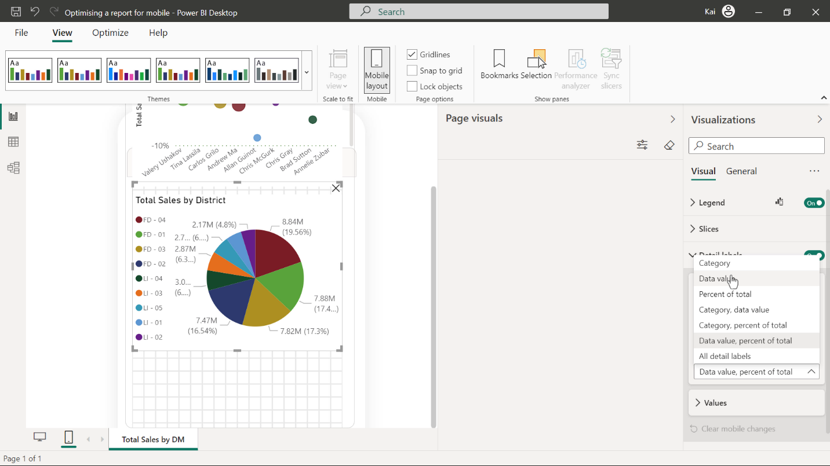

After you make changes to the visuals, you can select the desktop icon from the bottom left corner of the Power BI interface to go back to the desktop view of the report and confirm that the changes you made for mobile did not affect the original report version.

Your completed report should resemble the images below.

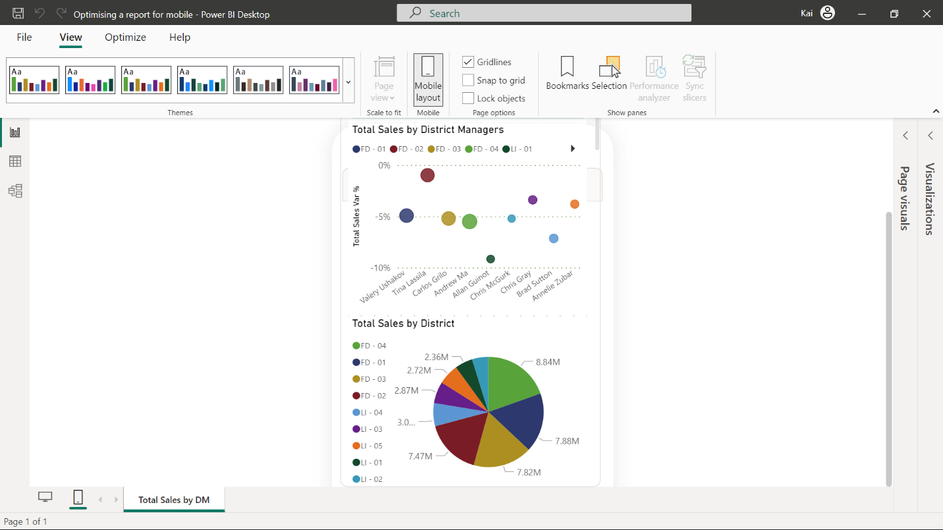

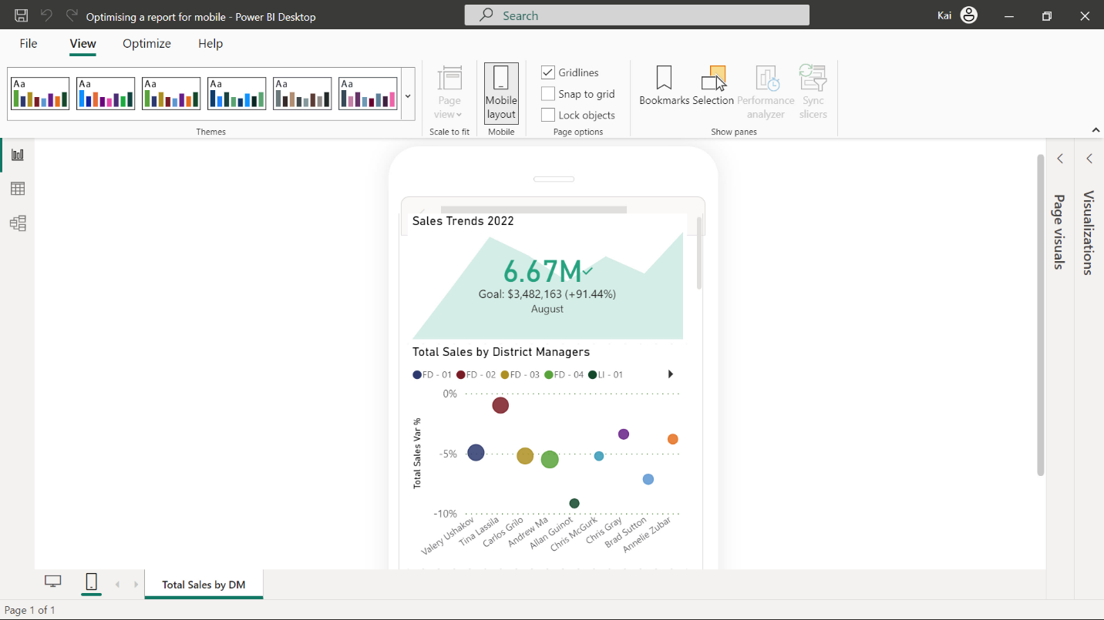

**Step 6: Save the Power BI project**

* Save your Power BI project to your local computer.

Make sure to provide an appropriate path to the file location.

**Conclusion**

With these steps, you have successfully optimized and formatted the Microsoft Power BI report for cellular devices.